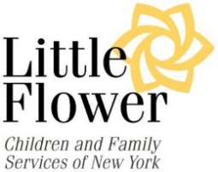
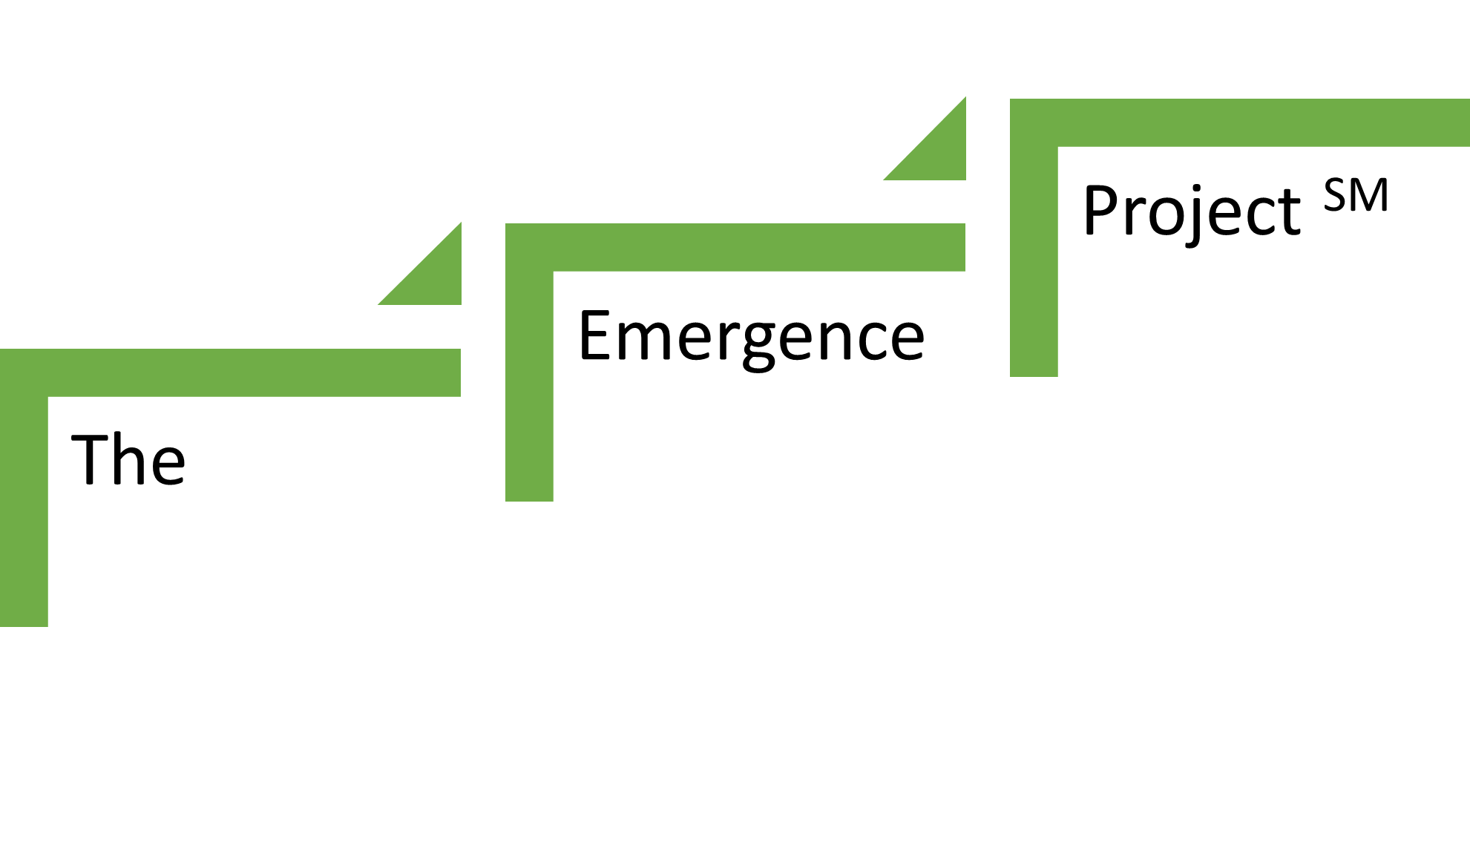

A Youth Leadership and Professional Development Program
Sponsored by Little Flower Child and Family Services

APPLICATION
Little Flower Child and Family Services launched a new, innovative youth development program in 2018 called The Emergence Project (TEP). All young adults between the ages of 16 and 21 currently engaged with Little Flower are eligible to join the program. Applications are now open for the Spring semester.

If you are interested in developing leadership skills and learning to work in a professional setting, this program is for you.

Over 12 weeks you will:
- Attend weekly after-school workshops and learn resume writing, public speaking and interview skills
- Interact with business professionals and learn how to perform in a professional setting
- Be placed in paid summer internships at businesses throughout New York City

The workshops will take place on Wednesday afternoons between 4:15 p.m. and 6:30 p.m. from February 22, 2023, through May 17, 2023.

Workshops will be led by business professionals and will introduce you to the worlds of finance, communications, law, and culture. All students who graduate from the program will be considered to participate in a 6-week paid summer internship in a professional location.

Our first graduates developed as leaders and became more confident at navigating foreign, and often uncomfortable, environments and situations.

“…I want other young adults to have the opportunity to participate in a program like this, because it opens up your mind and gives you the chance to grow.” – H., 20, Queens

“The most uncomfortable was being told to speak loudly. I was living life thinking my voice had no meaning.” – T., age 20, Brooklyn

This program has played a major role in my life because it gave me the opportunity to meet new people and it taught me so many things that I need to know as I become a young adult. I am more open to discovering new things and going new places” – P., age 16, Queens

To apply, please fill out this application and return it to Maquesha McKenzie at mckenzim@lfchild.org by January 25, 2023.

First Name: | Last Name:

Date of Birth: | Age: | Circle one:  Male Female | Ethnicities:

Current Address:

City: | State: | Zip Code:

Home Number: | Cell Number:

Email Address: | Best way to reach you:

Do you have access to a computer?

☐ YES ☐ NO

Current School:

Current Grade: | Expected Year of Graduation:

Please answer the following questions:

What qualities do you think a leader possesses?

Why do you want to join The Emergence Project?

